**MODULE: 1 (SDLC)**

**Que.** What is software? What is software engineering?

**Ans.** Software is a set of programs or sequences of instructions that allows the users to perform a well-defined function or some specified tasks.

Software engineering: - Software engineering is the multi-person construction of multi-version software.

**Que.** Explain types of software.

**Ans.** Among the various categories of software, the most common types include the following:

**Application software.**The most common type of software, application software is a computer software package that performs a specific function for a user, or in some cases, for another application. An application can be self-contained or a group of programs that run the application for the user.

**System software.** These software programs are designed to run computer applications and hardware. System software coordinates the activities and functions of the hardware and software. In addition, it controls the operations of the computer hardware and provides an environment or platform for all the other types of software to work in.

**Driver software.**Also known as device drivers, this software is often considered a type of system software. Device drivers control the devices and peripherals connected to a computer, enabling them to perform their specific tasks. Every device that is connected to a computer needs at least one device driver to function.

**Middleware.**The term middleware describes software that mediates between application and system software or between two different kinds of application software.

**Programming software.** Computer programmers use programming software to write code. Programming software and programming tools enable developers to develop, write, test and [debug](https://www.techtarget.com/searchsoftwarequality/definition/debugging) other software programs.

**Que** What is SDLC? Explain each phase of SDLC.

**Ans. SDLC (Software Development Life Cycle)** is a structure imposed on the development of a software product that defines the process for planning, implementation, testing, documentation, deployment, and ongoing maintenance.

**Planning**

Planning is the most important and fundamental stage in SDLC. It is performed by the senior members of the team with inputs from the customer, the sales department, market surveys and domain experts in the industry. This information is then used to plan the basic project approach and to conduct product feasibility studies in the economical, operational and technical areas.

**Analysis**

The goal of analysis is to determine where the problem is. This step involves decomposing the system into pieces, analyzing project goals, breaking down what needs to be created, and engaging users to define requirements.

**Design**

The design phase determines and defines the technical details of a project. For example, depending on the nature of the project, the design phase might include creating screen designs, prototypes, process diagrams, and system interfaces.

* During this phase, designers also determine the architecture, programming language, platforms, and user interface designs. This phase effectively takes the product vision and specifies

how that vision will come to life?

**Implementation**

* Implement the design into source code through coding.
* Combine all the modules together into training environment that detects errors and defects.
* A test report which contains errors is prepared through test plan that includes test related tasks such as test case generation, testing criteria, and resource allocation for testing.

**Testing**

* Testing starts once the coding is complete and the modules are released for testing. In this phase, the developed software is tested thoroughly and any defects found are assigned to developers to get them fixed.
* Retesting, regression testing is done until the point at which the software is as per the customer’s expectation. Testers refer SRS document to make sure that the software is as per the customer’s standard.

**Maintenance**

* Implement the changes that software might undergo over a period of time, or implement any new requirements after the software is deployed at the customer location.
* It also includes handling the residual errors and resolve any issues that may exist in the system even after the testing phase.
* Maintenance and support may be needed for a longer time for large systems and for a short time for smaller systems.

**Que** What is DFD? Create a DFD diagram on Flipkart.

**Ans.** A data flow diagram (DFD) maps out the flow of information for any process or system. It uses defined symbols like rectangles, circles and arrows, plus short text labels, to show data inputs, outputs, storage points and the routes between each destination.

Data flowcharts can range from simple, even hand-drawn process overviews, to in-depth, multi-level DFDs that dig progressively deeper into how the data is handled.

**DFD Diagram:**

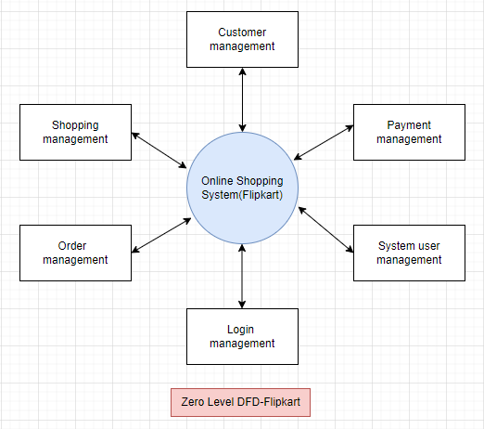

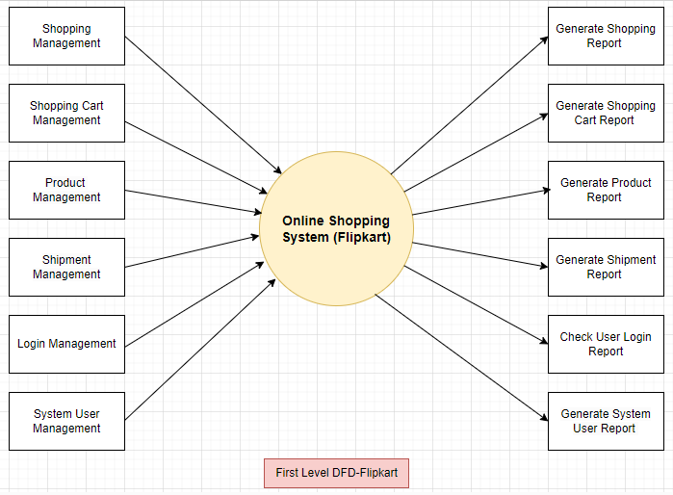

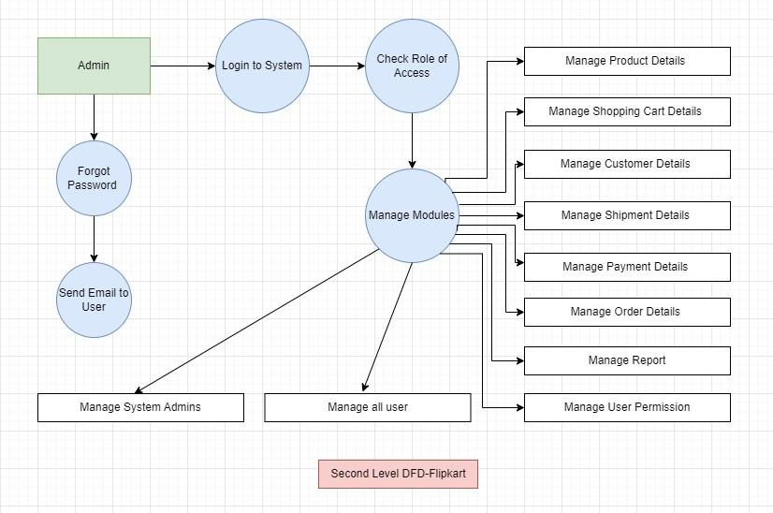

**Que** What is Flow chart? Create a flowchart to make the addition of two numbers?

**Ans.** A flowchart is a diagram that depicts a process, system or computer algorithm.

Flow Chart to Addition of Two Number: -

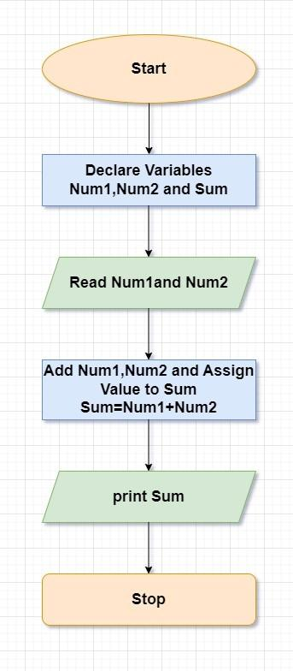

**Que.** What is Use Case Diagram? Create a use-case on bill payment on Paytm.

**Ans.** A use case diagram shows various use cases and different types of users the system has and will often be accompanied by other types of diagrams as well.

**Use Case Diagram of Paytm: -**

